How to Get Internet Service

1. Visit either Frontier Communications in St. Michaels, Arizona or NTUA Choice Wireless in Fort Defiance, Arizona (The building with the account services).
2. Make sure either of the services works in your area and choose the plan that is most appropriate for your particular household.
3. Schedule the installation time in your home and make sure any of the necessary fees are paid.

Frontier Communications location:

[**Address**](https://www.google.com/search?rlz=1C1NDCM_enUS718US723&sxsrf=ALeKk015gsY_dxiOrhpo8pfDL0N9hiEuuA:1596490733597&q=frontier+communications+retail+store+saint+michaels+address&stick=H4sIAAAAAAAAAOPgE-LWT9c3LMkyLy_LMNSSzU620s_JT04syczPgzOsElNSilKLixexWqcV5eeVZKYWKSTn5-aW5mVCFBQrFKWWJGbmKBSX5BelKhQnZuaVKORmJmckpuYUK0B1AwBwkICZbAAAAA&ludocid=16449627931898152570&sa=X&ved=2ahUKEwjbksC4___qAhU-FTQIHW3aD7sQ6BMwGHoECBUQAg)**:**AZ-264, St Michaels, AZ 86511

[**Phone**](https://www.google.com/search?rlz=1C1NDCM_enUS718US723&sxsrf=ALeKk015gsY_dxiOrhpo8pfDL0N9hiEuuA:1596490733597&q=frontier+communications+retail+store+saint+michaels+phone&ludocid=16449627931898152570&sa=X&ved=2ahUKEwjbksC4___qAhU-FTQIHW3aD7sQ6BMwG3oECBcQAg)**:**[(928) 871-3814](https://www.google.com/search?q=frontier+communications+st+michaels&rlz=1C1NDCM_enUS718US723&oq=Frontier+Communications+St+Michaels&aqs=chrome.0.0j46j0l2.8127j1j8&sourceid=chrome&ie=UTF-8)

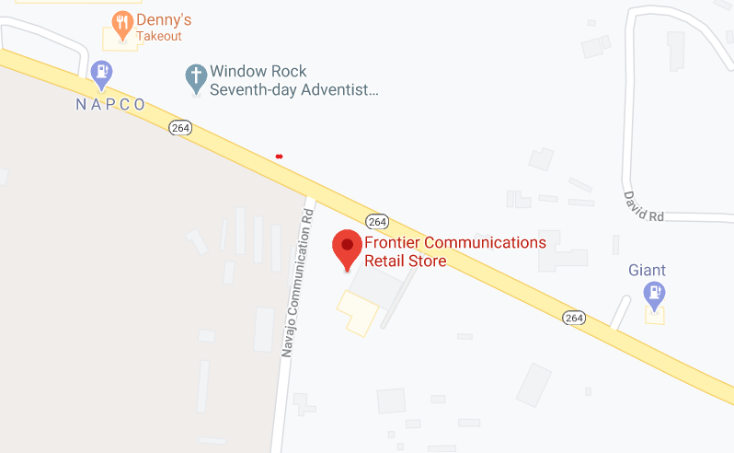

NTUA Choice Wireless location:

[**Address**](https://www.google.com/search?rlz=1C1NDCM_enUS718US723&sxsrf=ALeKk028Z7d0nnN2STEWjlWJnHdKq9py_w:1596490810175&q=choice+ntua+wireless+fort+defiance+address&stick=H4sIAAAAAAAAAOPgE-LVT9c3NEw2KowvNzJO0pLNTrbSz8lPTizJzM-DM6wSU1KKUouLF7FqJWfkZyanKuSVlCYqlGcWpeYAhRXS8otKFFJS0zIT84ByUMUAXRZYql0AAAA&ludocid=17319654619950025239&sa=X&ved=2ahUKEwiHlILd___qAhW_CTQIHcLZCUYQ6BMwEHoECBQQAg)**:**Indian Rte 12, Fort Defiance, AZ 86504

[**Phone**](https://www.google.com/search?rlz=1C1NDCM_enUS718US723&sxsrf=ALeKk028Z7d0nnN2STEWjlWJnHdKq9py_w:1596490810175&q=choice+ntua+wireless+fort+defiance+phone&ludocid=17319654619950025239&sa=X&ved=2ahUKEwiHlILd___qAhW_CTQIHcLZCUYQ6BMwE3oECBUQAg)**:**[(928) 729-6421](https://www.google.com/search?q=ntua+choice+broadband&rlz=1C1NDCM_enUS718US723&oq=NTUA+Choice+Broadband&aqs=chrome.0.0.6895j0j8&sourceid=chrome&ie=UTF-8)

